**Model Questions (Module 4)**

1. *An electron is constrained to a one-dimentional potential box of 0.1nm side. Find the energy eigen value in eV for 3rd excited state.*

**Ans:** Energy eigen values for the one dimensional potential box is given as;

**En = n2h2/8mL2**

where the symbols are;

n = quantum numbers/allowed energy levels

h = Planck’s constant

L = width of the box

Hints: Here, L = 0.1 nm = 0.1×10-9 m

3rd excited states means n = 4, put these values and find the energy values. At, last convert the energy to eV by dividing 1.6×10-19

**Points to remember:**

Ground state means n = 1 (also known as zero-point energy), 1st excited state means ‘n’ = 2 etc…

So, **En ~ n2**, (n is known as allowed energy levels/quantum numbers = 1, 2, 3 …….)

**En ~ 1/L2**

**‘ΔE’** (energy levels difference) is **not equi-spaced.**

Energy eigen valueis **quantized** (so also **momentum**)

**For 3-D,**

The **energy values** will be;

The **Eigen function** is;

Where nx, ny, nz are allowed energy levels/quantum numbers (1, 2, 3, ……)

1. *A particle of mass 'm' is enclosed inside a potential well of infinite height. Show that maximum de-Broglie wavelength of the particle is twice the width of the well.*

**Ans.:** We have E = n2h2/8mL2

Also, E = p2/2m

Comparing both, we get p = nh/2L

We have, de-Brogle equation;

**λ = h/p = 2L/n**

So, λ will be max, for n = minimum i.e., n = 1

Implies λ = 2L = twice the width of the well

1. *The ground state energy of a particle, trapped in a one-dimensional infinite potential well is 10 J. Find the energy in eV of the particle in first excited state.*

**Hint**: Ground state energy (E1) is given,

Find E2 = ?

We have, **En = n2E1. So** E2 = 4 E1.

Finally, convert the energy value in Joule to eV.

1. *Write the time independent Schrödinger wave equation in three dimensions. Write the expression for each term of the equation.*

**Ans.**: The **time independent** Schrödinger wave equation in three dimensions;

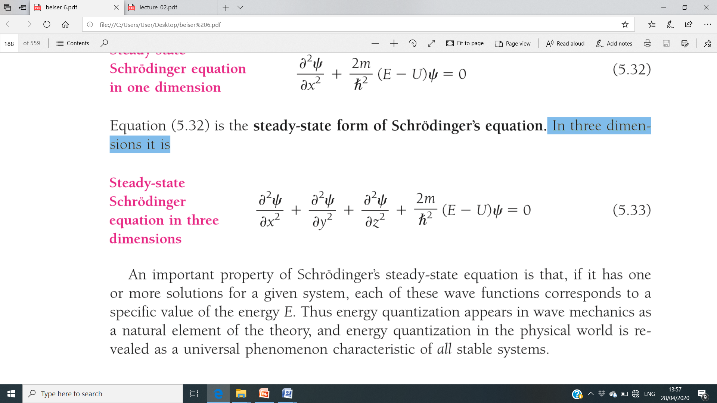

Or,

In one dimension (say x-axis), the **time independent** Schrondiger wave equation;

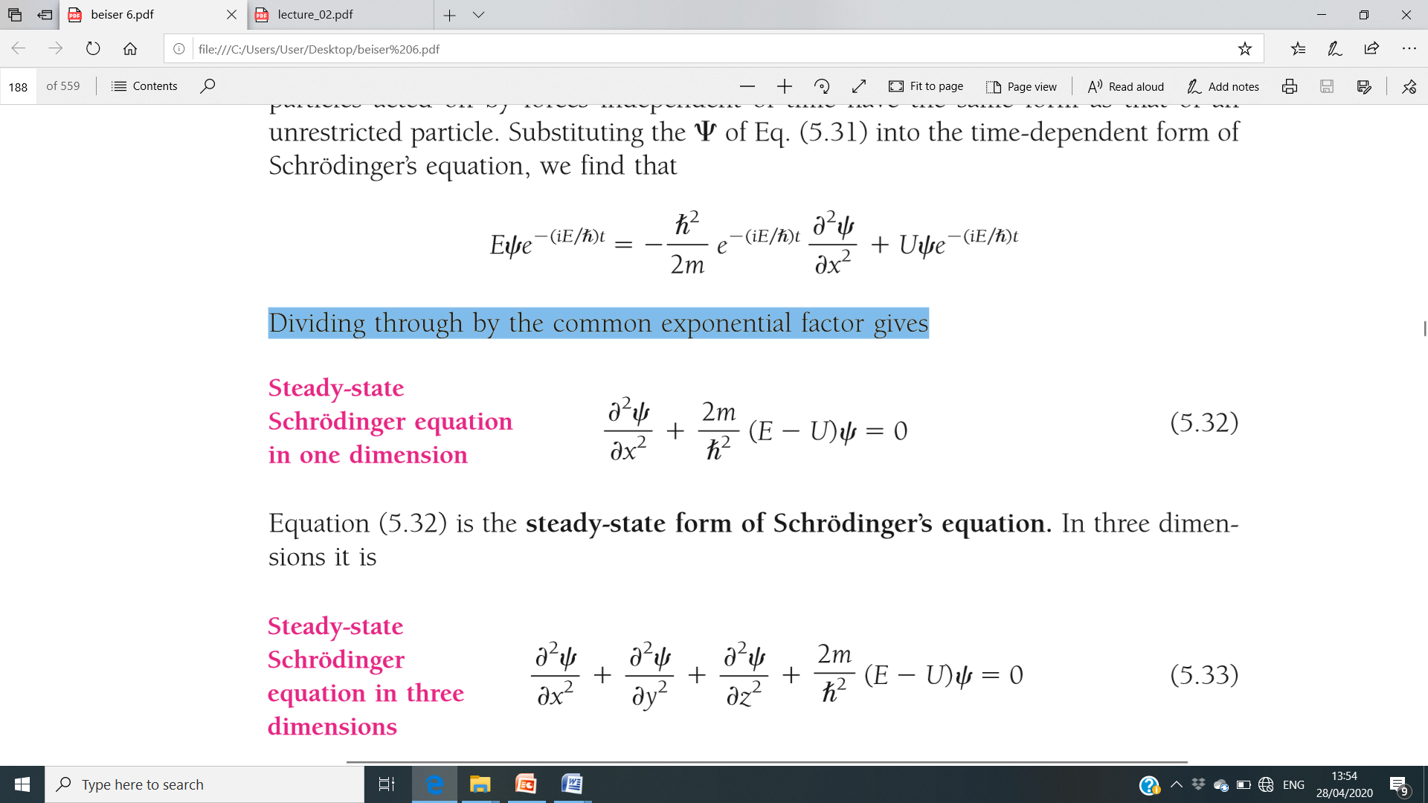

1. *Calculate the Zero-point energy for a particle in an infinite potential well for an electron confined to a 1 nm atom.*

**Hint**: Calculate E1 (zero-point energy/ground state energy)

Given, L = 1 nm, h, m (mass of electron are given)

1. *For a particle inside a box, state the positions where the potential is maximum.*

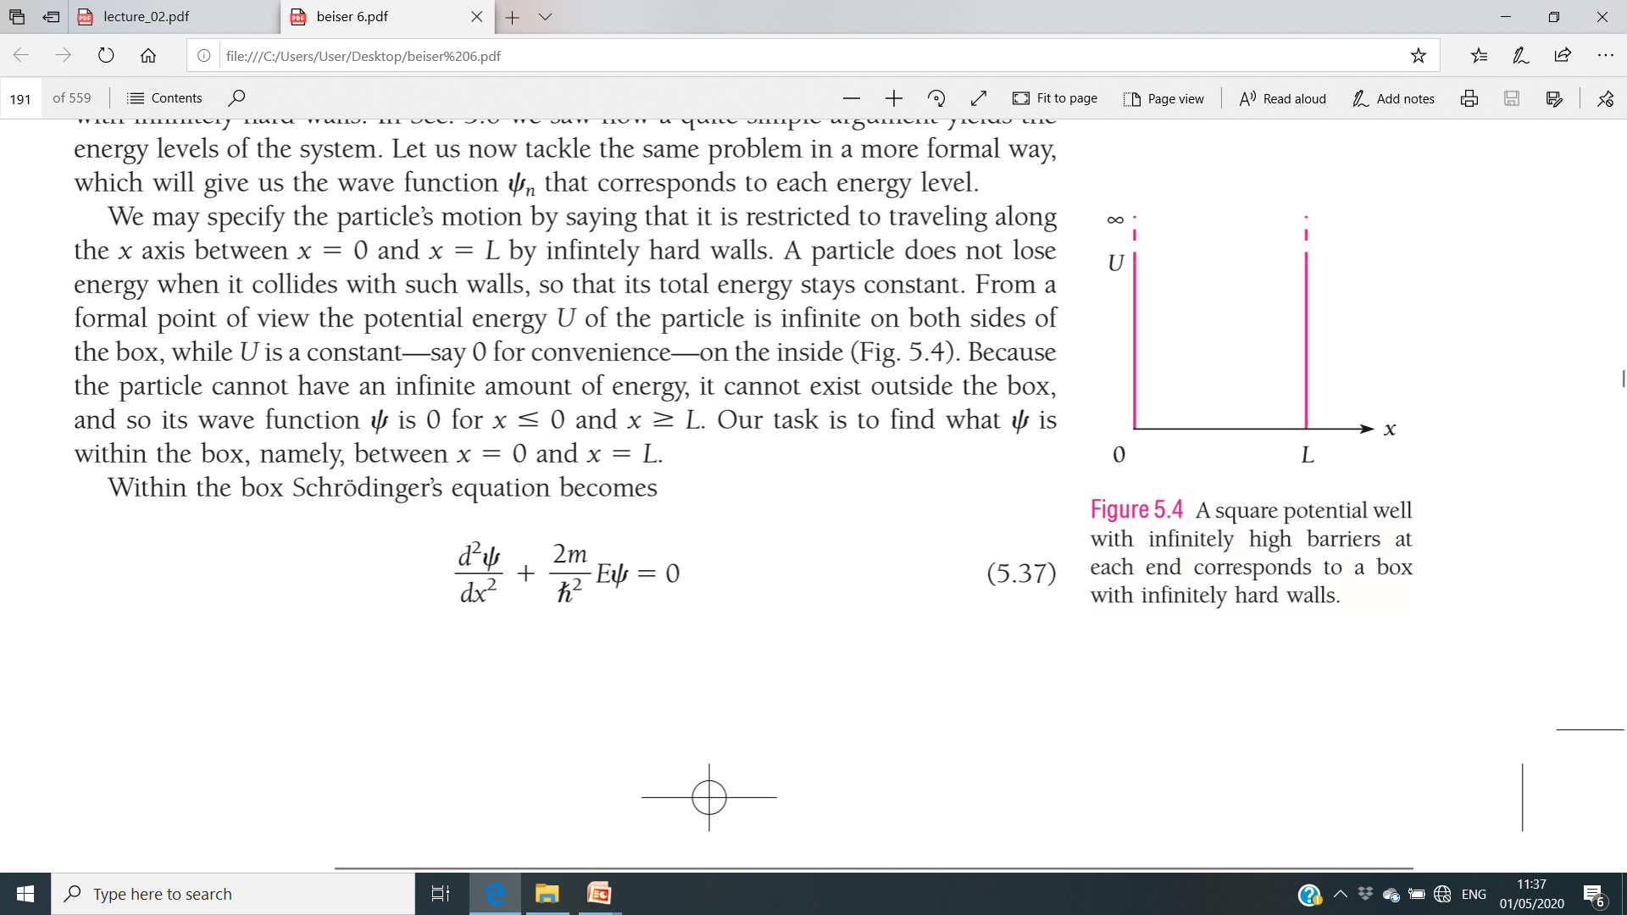

Infinite potential well

From the figure, you will find that the potential energy **U** (or **V**) of the particle in a box is **maximum** (infinite) on both sides of the box (**x =0** and **x = L**), while U is constant (say 0 for convenience) on the inside of the box.

1. *What is the eigenfunction of a particle trapped in an infinite deep potential well in its first excited state?*

**Ans.:** The one-diemstional wave function for particle in a box,

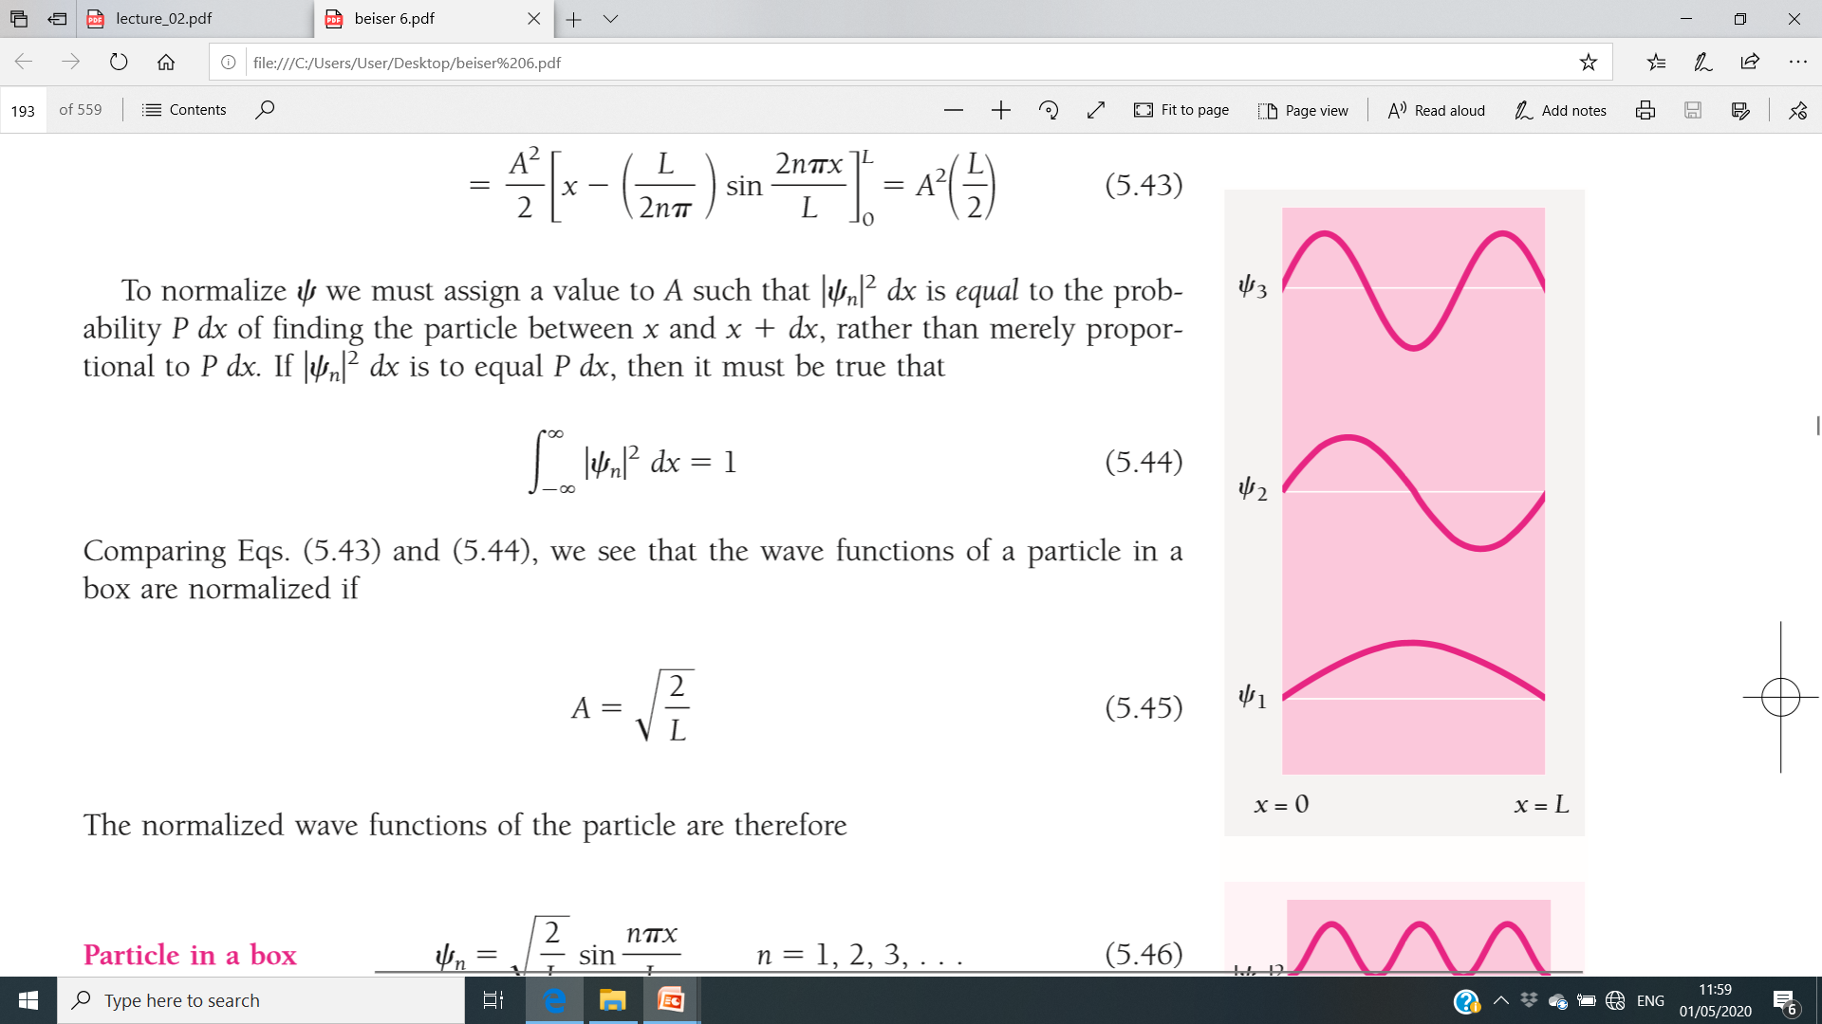

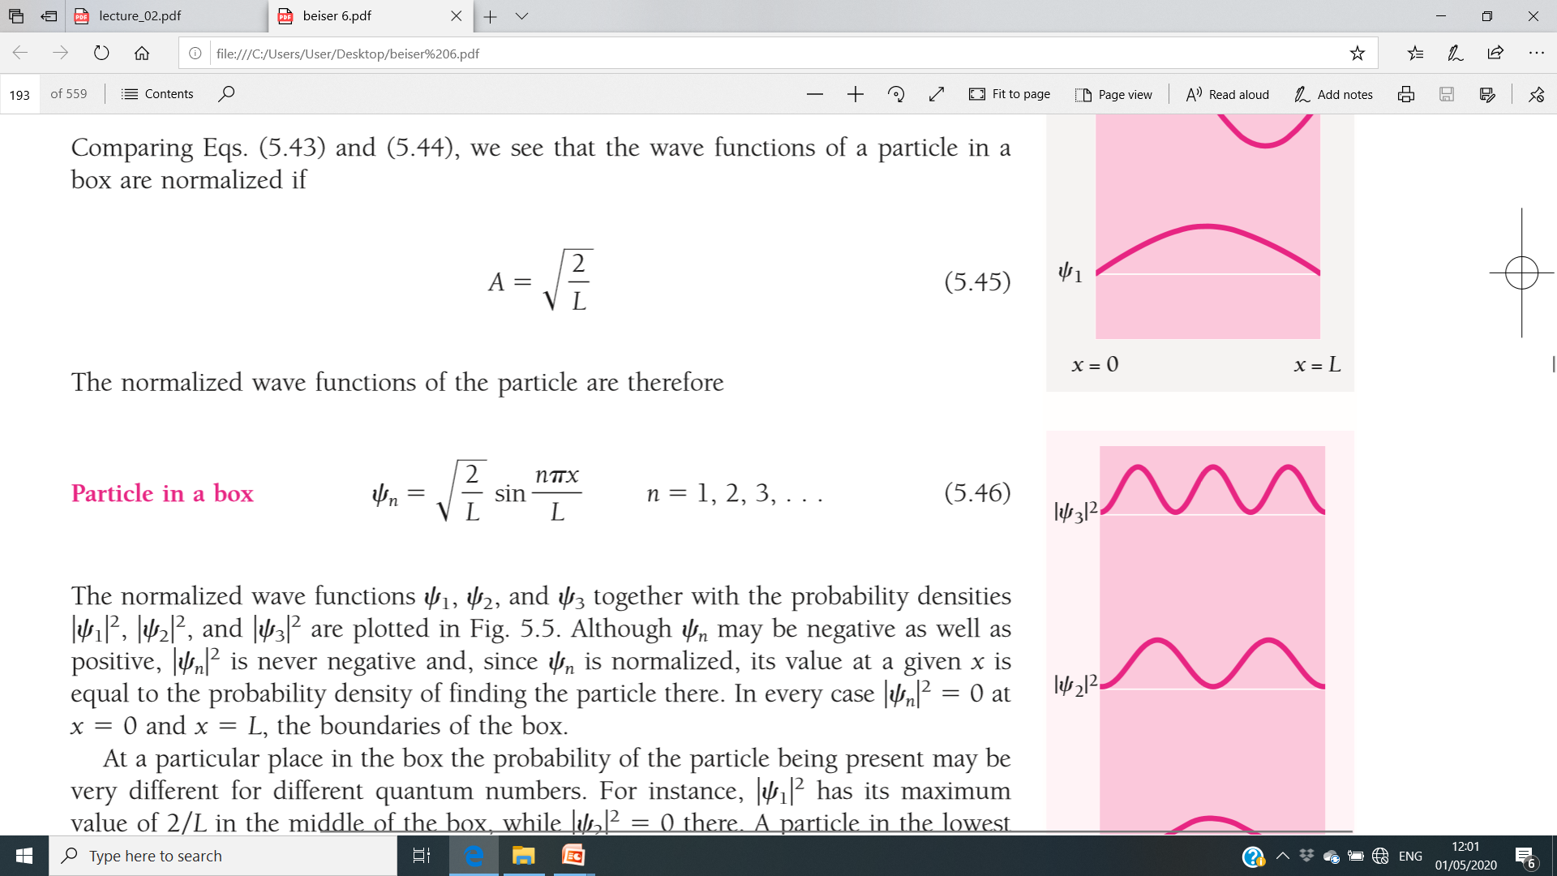

Hint: 1st excited states means, n = 2. So,

put the value ‘n = 2’ in the wave equation.

1. *Draw the Eigen functions and the corresponding probability densities for particle in a box/infinite potential well for energy levels n = 1, 2 , 3 (ground, 1st excited and the 2nd excited states).*

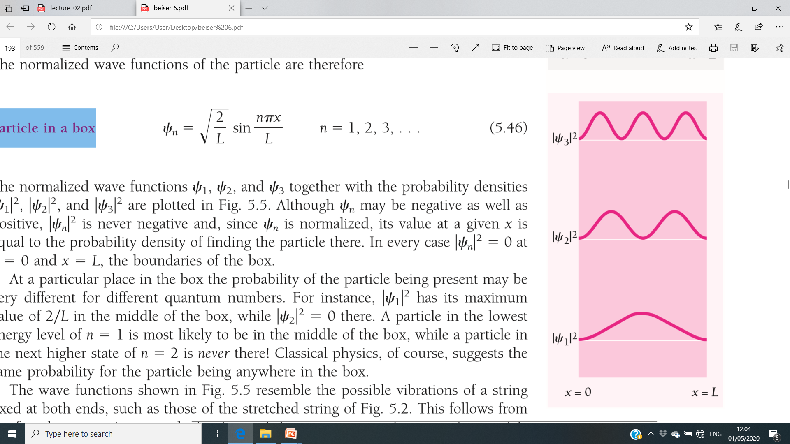



Probability density

The probality density is always **positive**.

For **n = 1**, max. Probability density is around middle of the box (**x = L/2**) whereas, it is **zero** at the middle at L/2 for **n = 2, 4, 6**…….

It exhibits **perfect symmetry** for all the allowed levels at L/2.

1. *Write the dimension of a three-dimensional wave function.*

**Ans.:** The dimension of a three-dimensional wave function is **L-3/2**

*The dimension of a one-dimensional wave function is* ***L-1/2***

*The dimension of a two-dimensional wave function is* ***L-1***

*The probability density has a dimension of* ***L-3***

1. *Write the Schrodinger’s time independent wave equation for a free particle moving along x-axis with low speed.*

In one dimension (say x-axis), the **time independent** Schrondiger wave equation for a **free particle moving with low speed**;

The limitation of the Schrondiger wave equation is that, the particle motion should be **non-relativistic one** i.e., *particle speed « speed of light.*

1. *Find out the* ***energy gap*** *between the 2nd and 3rd excited states of an electron confined in a potential box of length 4Å.*

Ans.: Energy Eigen values for the one dimensional potential box are given as;

**En = n2h2/8mL2**

Here, m = 9.1×10-31 kg, h = 6.62×10-34 J/s, L = 4Å = 4×10-10 m

For **2nd excited state, n = 3**

For **3rd excited state, n = 4**

Put these values and find the values of **E3** and **E4.**

The **energy gap** (ΔE) **= E4 –E3**

1. *The energy of an electron in an one dimensional potential box of length 4 Å is 9000 J. Find the order of the state and the momentum of the electron in this state.*

**Hint**: En = 9000 J

We have, En = n2h2/8mL2,

**Aim**: to find ‘**n**’

Known values are, h, m, L. put these values and find out the value of ‘**n**’.

1. *What do you mean by expectation value of an observable in quantum mechanics? Write down the expectation value of position of a single particle.*

**Ans.:** *In QM, the observable quantities are expressed in terms of weighted average of the eigen values. The weighted average value is known as the expectation value. The expectation value is nothing but to extract information of the observable quantities from the system.*

Let ‘O’ is any observable quantity (say position, momentum, energy etc…), then the expectation value can be written as;

Where p = probability density =

The expectation value of the **position** (say r in 3D) of a single particle is defined as;

In one-dimension (say ‘x’),

1. *An electron confined in a one dimensional box of width* ***L*** *is known to be in its first excited state. Determine the probability density of electron in the central half.*

**Ans.:** The eigen wave function of an electron in the **first excited state** (n = 2) of a one dimensional box of width L is given by;

**Aim:** to find the probability density at x = L/2

Probability density = =

After putting the value at x = L/2, probability density = 0

1. *The ground state energy of a particle in an infinite one-dimensional potential well is 8 eV. If the width of the well is halved, what is the new ground state energy?*

**Hint**: we have **En ~ 1/L2** (for a particle in a box)

Here, the width (say L’) is reduced to half means L’ = L/2

E1’ ~ 1/( L/2)2 = **4E1 =** 4 times increase

1. *Prove that the momentum (linear) of a particle in a one-dimensional well of infinite height is quantized.*

We have, the energy eigen values for a particle in a one dimensional well/box is given as;

**En = n2h2/8mL2**

We have,

E = p2/2m

Equating this value from the above formula, we get

p = nh/2L = nh(h/2L) = nh’ (where h’ = h/2L)

*So,* *momentum is expressed in the terms integral (n) multiple of h and hence, is quantized.*

1. *A beam of electrons are incident on a barrier of height 6.0 eV and 0.2 nm wide. Find the energy they should have if 1% of them are to tunnel through the barrier.*

**Hint**: Transmission probability (tunneling through the potential barrier) = 1% = 0.01

Barrier height = potential energy (U) = 6 eV, barrier width (L) = 0.2 nm.

**Aim: to find E**

We have the approximate value of the **transmission probability** (T) is =e-2k2L

So, 0.01 = e-2k2L

Taking logarithmic on both sides,

Log (0.01) = -2k2L

Log (10-2) = -2k2L

-2 = -2 k2L, k2L = 1

⇒ k2 = 1/L

or = 1/0.2 nm = 5×10-11 m

**Find the value E,** after putting the value of m, U and ℏ etc..

1. *Electrons with energy 3 eV are incident on a potential barrier of 10 eV high and 4nm wide. Find the transmission probability.*

**Hint**: see the solution of Q.17 (here, you have to find out T, the parameters E, U and L are given).

1. *A particle limited to the x axis has the wave function*

Find (a) the probability that the particle can be found between x = 0.3 and x = 0.5 (b) Find the expectation value of the particle's position.

**Ans.:** The probability of finding a particle (along any direction, here it is in x-dir) in a specified position defined by (x1 and x2)

Px1x2 = dx = dx = dx (evaluate the integration and find the value).

Similarly, the expectation value for the position can be written as;

dx = dx (solve the integration and find the value).

*Also, see the ppt shared in the ERP (Module 4_Part IV_01.05.2020) for more information.*

1. *Find the expectation value of the momentum* ***<p>*** *of a particle trapped in a box* ***L*** *wide.*

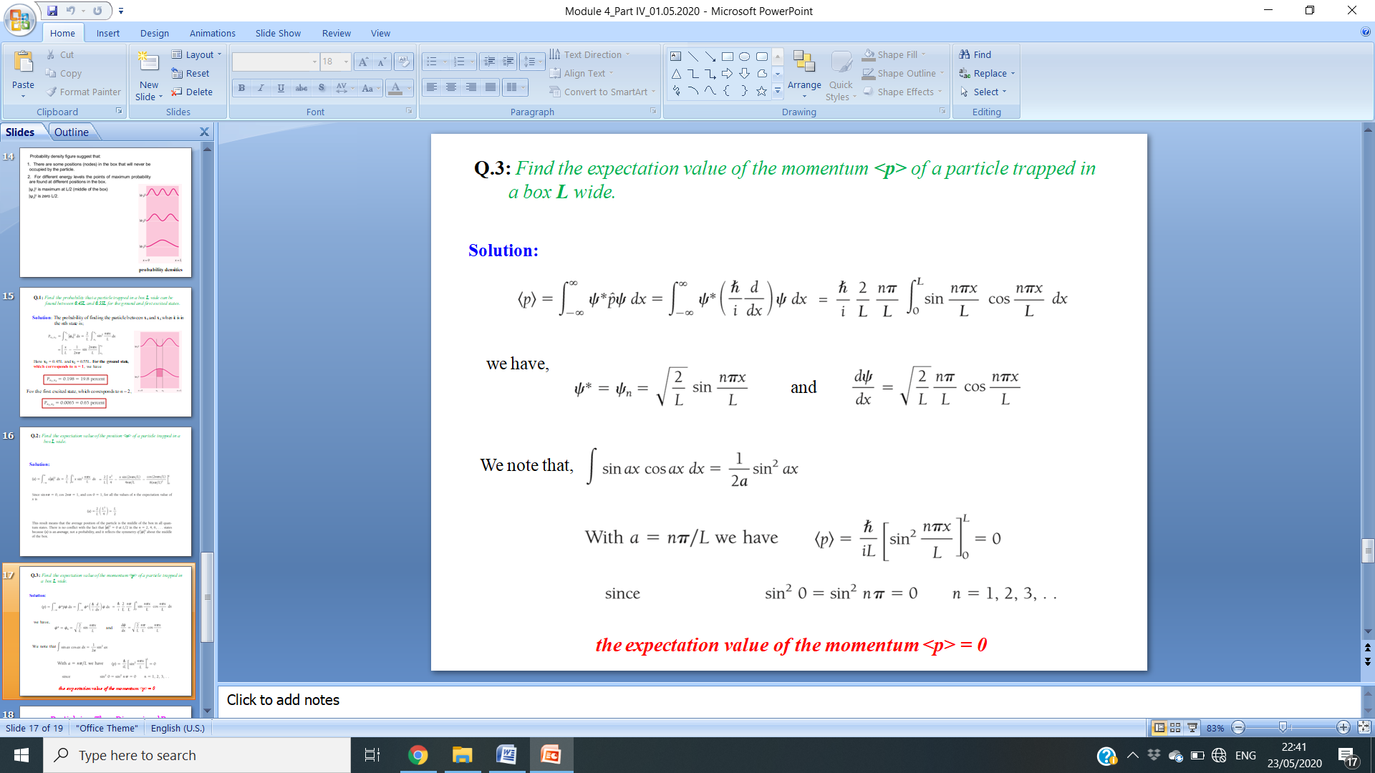**Ans.:**

**\*\*\*\*see the ppt(s) of the module 4 for additional numerical and the theory\*\*\*\*\***